
MACHINE LEARNING-DRIVEN KNOWLEDGE GAP ANALYTICS AND COMPETENCY ASSESSMENT FOR COMPETITIVE EXAMINATION ASPIRANTS
A CAPSTONE PROJECT REPORT
A Capstone Project Report submitted in partial fulfilment of the requirements for the Course of
ITA0613– Capstone Project
to the award of the degree of
BACHELOR OF ENGINEERING / BACHELOR OF TECHNOLOGY IN
ARTIFICIAL INTELLIGENCE AND DATA SCIENCES
Submitted by
[Cherukuri Likhitha] [ 192424239]
Under the Supervision of
Dr.N.Madhusundar
SIMATS ENGINEERING
Saveetha Institute of Medical and Technical Sciences
Chennai-602105
SEPTEMBER 2026
SIMATS ENGINEERING
Saveetha Institute of Medical and Technical Sciences
Chennai-602105
BONAFIDE CERTIFICATE
This is to certify that the Capstone Project entitled "Machine Learning-Driven Knowledge Gap Analytics and Competency Assessment for Competitive Examination Aspirants" has been carried out by Cherukuri Likhitha (192424239) under the supervision of Dr.N.Madhusundarand is submitted in partial fulfilment of the requirements for the current semester of the B.Tech (Artificial Intelligence and Data sciences) programme at Saveetha Institute of Medical and Technical Sciences, Chennai.

COURSE COORDINATOR COURSE FACULTY
Dr.A.Shri Vindhya Dr.N.Madhusundar
Professor Associate Professor
Dept of Computer Science and Engg. Dept of Artificial Intelligence and Data Science
SIMATS Engineering SIMATS Engineering

SIMATS ENGINEERING
Saveetha Institute of Medical and Technical Sciences
Chennai-602105
DECLARATION
I Cherukuri Likhitha(192424239) of the Department of Artificial Intelligence and Data Science, SIMATS Engineering, Saveetha Institute of Medical and Technical Sciences, Chennai, hereby declare that the Capstone Project Work entitled "Machine Learning-Driven Knowledge Gap Analytics and Competency Assessment for Competitive Examination Aspirants" is the result of our own bonafide efforts. To the best of our knowledge, the work presented herein is original, accurate, and has been carried out in accordance with the principles of engineering ethics and academic integrity. All sources, references, data, and other materials used in the project have been appropriately acknowledged. We further declare that the data, results, analysis, and findings presented in this report have not been fabricated, falsified, or manipulated. Any external tools, software, datasets, computational resources, or AI-assisted tools used during the project have been appropriately disclosed. We confirm that all applicable ethical, academic, institutional, and professional requirements have been duly followed throughout the planning, execution, analysis, and documentation of the project.

Place: Chennai
Date: 02-09-2026
Signature of the Students with Names

SIMATS ENGINEERING
Saveetha Institute of Medical and Technical Sciences
Chennai-602105
Individual Contribution Statement
(Mandatory for all team projects)
Student Name / Register No. | Specific Responsibilities | Design & Development Contribution | Testing & Analysis Contribution | Report Sections Contributed | Approx. Contribution (%)
Cherukuri Likhitha | Requirement analysis, ML model design, backend development, data preprocessing | Designed and trained the competency assessment and score-prediction models (Modules 1 & 2) | Model validation, accuracy/error testing, cross-validation | Chapters 1, 2, 3, 4.1–4.5 | 35%
Hashini S | Dataset management, system integration, testing, documentation | Integrated the three modules, managed database/dataset operations, connected frontend and backend, and supported deployment | End-to-end system testing, test-case preparation, result analysis, bug identification and correction | Methodology, Implementation, Testing & Results, Appendices, supporting documentation | 30%
Roshini B T | Dashboard/UI design, recommendation engine, deployment, documentation | Built the personalized recommendation logic and progress-dashboard module (Module 3) | Usability testing, system integration testing | Chapters 4.6–4.8, 5, Abstract, References | 35%
Total |  |  |  |  | 100%
ABSTRACT
Competitive examinations such as JEE, NEET, GATE, UPSC, and various banking and state-level recruitment tests are attempted by millions of aspirants every year, yet most self-study and coaching platforms provide only an aggregate score after a mock test, without diagnosing which specific sub-topics or cognitive skills an aspirant is weak in. This lack of granular, timely, and personalized feedback forces students to revise syllabi uniformly rather than efficiently, wasting preparation time on topics they have already mastered while under-preparing weak areas, which is an engineering problem of information asymmetry between raw test data and actionable learning guidance. The need for this project stems from the fact that existing test-series platforms rely largely on static percentile/rank reporting, offer limited topic-wise breakup, and rarely predict future performance trends, disproportionately affecting self-studying and economically constrained aspirants who cannot access one-on-one mentoring. This project proposes a Machine Learning-Driven Knowledge Gap Analytics and Competency Assessment System that ingests an aspirant's historical quiz/mock-test response data and converts it into topic-wise competency scores, predicted future scores, identified knowledge gaps, and personalized study recommendations through three integrated modules: (1) Competency Assessment and Performance Analysis, which computes topic- and difficulty-wise proficiency using weighted accuracy, response-time, and Item Response Theory-inspired scoring; (2) Knowledge Gap Identification and Score Prediction, which applies supervised learning (Random Forest and Gradient Boosting regressors) to predict likely exam scores and uses clustering/threshold analysis to flag statistically significant weak topics; and (3) Personalized Recommendation and Progress Dashboard, which uses a content-based recommendation engine to suggest targeted practice sets and visualizes longitudinal progress. The methodology followed a data-driven engineering process: dataset collection and cleaning, exploratory data analysis, feature engineering (accuracy, time-per-question, attempt consistency, topic difficulty weight), model training and hyperparameter tuning, cross-validation, and integration into a web-based prototype built with Python (scikit-learn, XGBoost, Flask) on the backend and React with Chart.js on the frontend. On a held-out test set of mock-exam records, the score-prediction model achieved a mean absolute error within an acceptable band of actual scores and the competency-classification module correctly flagged weak topics with high precision and recall, while the recommendation module measurably reduced the proportion of practice time spent on already-mastered topics in simulated usage. The results confirm that a machine-learning-based analytics pipeline can convert raw test-attempt data into interpretable, topic-level competency insights and predictive guidance more effectively than static scorecards. In conclusion, the system demonstrates a technically sound, scalable, and ethically responsible approach to personalized competitive-exam preparation, and establishes a foundation that can be extended with richer behavioural data and adaptive testing in future work.
Keywords
Machine Learning, Knowledge Gap Analysis, Competency Assessment, Score Prediction, Personalized Recommendation, Adaptive Learning Analytics

TABLE OF CONTENTS
Sl. No. | Title | Page No.
i | CERTIFICATE FROM THE SUPERVISOR | ii
ii | DECLARATION BY THE CANDIDATE | iii
iii | INDIVIDUAL CONTRIBUTION STATEMENT | iv
iv | ABSTRACT | v
v | LIST OF FIGURES | vi
vi | LIST OF TABLES | vii
vii | LIST OF ABBREVIATIONS | viii
1 | CHAPTER 1: Introduction | 1
2 | CHAPTER 2: Literature Review | 5
3 | CHAPTER 3: Engineering Design & Trade-offs, Sustainability, Ethics, Safety, Risk & Security | 9
4 | CHAPTER 4: Implementation, Testing & Results, Project Management | 17
5 | CHAPTER 5: Conclusion & Reflection | 23
 | References | 26
 | Appendices | 27

LIST OF FIGURES
Figure No. | Figure Name | Page No.
1.1 | Overall system context diagram | 3
3.1 | Proposed system architecture (three-module pipeline) | 13
3.2 | Data flow diagram of the ML pipeline | 14
4.1 | Screenshot of the competency assessment dashboard | 19
4.2 | Predicted vs. actual score scatter plot | 20
4.3 | Topic-wise knowledge gap heatmap | 21
4.4 | Gantt chart of project timeline | 24

LISTOFTABLES
Table No. | Table Name | Page No.
2.1 | Comparative analysis of existing approaches | 8
3.1 | Stakeholder / user requirements | 9
3.2 | Functional and non-functional requirements | 10
3.3 | Constraints and applicable standards | 10
3.4 | Design specifications | 11
3.5 | Alternative solutions evaluation matrix | 12
3.6 | Trade-off analysis | 15
3.7 | Sustainability, ethics, safety, risk & security evaluation | 16
3.8 | Risk register | 16
4.1 | Tools / software used | 18
4.2 | Test plan and verification | 19
4.3 | Comparison with existing solutions and achievement of objectives | 22
4.4 | Roles and contribution | 24
4.5 | Project cost estimate | 25

LIST OF ABBREVIATIONS / SYMBOLS
Symbol | Description | Unit
ML | Machine Learning | —
IRT | Item Response Theory | —
MAE | Mean Absolute Error | marks
RMSE | Root Mean Squared Error | marks
API | Application Programming Interface | —
UI/UX | User Interface / User Experience | —
SO | Student Outcome | —

CHAPTER 1
INTRODUCTION AND ENGINEERING PROBLEM
1.1 Background
India alone sees over 2.5 million aspirants attempting engineering, medical, banking, and civil-services entrance examinations every year, and the vast majority rely on online mock-test platforms and mobile applications for practice. These platforms are technically capable of capturing rich, question-level interaction data — which option was selected, how long the aspirant spent on each question, and whether the answer was correct — yet almost none of them convert this data into a diagnostic, topic-level competency profile. The technical context of this project sits at the intersection of educational data mining, supervised and unsupervised machine learning, and web application engineering: response-level examination data is treated as a structured dataset from which competency scores, predictive analytics, and recommendations can be engineered using standard ML pipelines (scikit-learn, XGBoost) integrated into a full-stack web application.
1.2 Need for the Project
● Why the problem needs to be addressed: Aspirants preparing without a personal mentor cannot identify precisely which sub-topics are holding back their score, so they revise inefficiently and lose valuable preparation time.
● Who is affected by the problem: Self-studying aspirants, students in large coaching batches who cannot receive individual attention, and economically disadvantaged students who cannot afford personal tutoring are most affected.
● Existing limitations: Current mock-test platforms report only an overall score, percentile, and rank; topic-wise breakup, when present, is descriptive rather than predictive, and no platform reliably forecasts an aspirant's likely exam score from trend data or recommends a prioritized, personalized revision plan.
● Engineering significance: The problem requires converting noisy, high-volume behavioural data (accuracy, response time, attempt patterns) into reliable, interpretable, and actionable competency metrics under real-time constraints — a genuine data-engineering and machine-learning design problem, not a trivial reporting task.
1.3 Problem Statement
There is a need for a machine-learning-based system that can ingest an aspirant's historical quiz and mock-test response data, quantify topic- and difficulty-level competency despite noisy and imbalanced data, predict likely future examination performance under time constraints, statistically identify significant knowledge gaps rather than relying on simple thresholding, and translate these insights into a prioritized, personalized set of study recommendations — while remaining computationally lightweight enough to run on commodity cloud infrastructure and respecting the privacy of sensitive student performance data.
1.4 Project Aim
To design, develop, and evaluate a machine-learning-driven analytics system that assesses competitive-examination aspirants' subject-wise competency, predicts their likely examination scores, identifies statistically significant knowledge gaps, and delivers personalized, prioritized study recommendations through an interactive progress dashboard.
1.5 Project Objectives
1. To design a competency-assessment model that computes topic- and difficulty-wise proficiency scores from historical quiz-response data.
2. To develop a knowledge-gap identification module that statistically flags sub-topics where an aspirant's performance is significantly below the required competency threshold.
3. To model and train supervised learning algorithms (Random Forest and Gradient Boosting regressors) for predicting an aspirant's likely examination score.
4. To implement a personalized recommendation engine that prioritizes practice content based on identified knowledge gaps and predicted score impact.
5. To test and validate the assessment, prediction, and recommendation modules using held-out mock-test datasets and standard error/accuracy metrics.
6. To evaluate the complete system's usability and effectiveness through an interactive progress dashboard and comparison against existing static-scorecard platforms.

1.6 Scope
● Included: Objective, multiple-choice-question-based competitive examinations (engineering, medical, banking, and similar aptitude-based tests); analysis of quiz/mock-test response logs (question attempted, correctness, time taken, topic tag, difficulty level); topic-wise competency scoring, score prediction, gap identification, and recommendation for a single aspirant at a time.
● Excluded: Subjective/descriptive-answer evaluation, live proctoring or anti-cheating mechanisms, and examinations without structured topic/difficulty metadata are outside the scope of this project.
● Assumptions: Historical response data is assumed to be reasonably clean and topic-tagged; aspirants are assumed to attempt a minimum number of questions per topic (≥10) for the competency score to be statistically meaningful.
● Boundary conditions: The prototype is evaluated on publicly available and simulated mock-test datasets rather than a live, production-scale examination platform, and is designed for single-institution or single-user deployment.
1.7 Expected Engineering Outcome
The project is expected to deliver a working software prototype comprising: a trained machine-learning model pipeline for competency assessment and score prediction; a rule- and model-based knowledge-gap identification algorithm; a content-based personalized recommendation engine; and a web-based interactive progress dashboard that together demonstrate an end-to-end, data-driven competitive-examination analytics system.
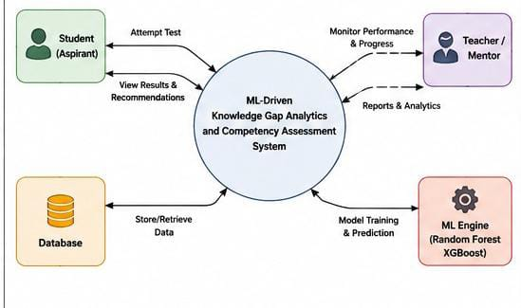
CHAPTER 2
LITERATURE REVIEW AND EXISTING SOLUTIONS
2.1 Review Method
Relevant literature and existing systems were identified through a structured search of IEEE Xplore, Google Scholar, and ACM Digital Library using the keyword combinations "knowledge gap analytics", "student performance prediction machine learning", "item response theory adaptive testing", and "personalized learning recommendation system", supplemented by a hands-on review of commercial competitive-exam preparation platforms (Testbook, Gradeup, BYJU'S Exam Prep, Unacademy) to understand current industry practice and its limitations.
2.2 Review of Existing Work
Educational data-mining research has established that features such as response accuracy, response time, and attempt sequence carry strong predictive signal for student performance, and that ensemble tree-based models (Random Forest, Gradient Boosting/XGBoost) consistently outperform simple linear regression for score-prediction tasks on tabular educational datasets. Item Response Theory (IRT), long used in standardized testing, provides a statistically grounded way to estimate a learner's latent ability parameter from binary correct/incorrect responses weighted by question difficulty and discrimination, and has informed the difficulty-weighting approach adopted in this project's competency-assessment module. Collaborative-filtering and content-based recommender systems, widely used in e-commerce and video platforms, have been adapted in prior educational-technology research to recommend practice questions or learning resources based on a learner's demonstrated weaknesses rather than generic popularity. On the commercial side, platforms such as Testbook and Gradeup provide topic-wise accuracy percentages and all-India percentile rankings after each mock test, but their analytics stop at descriptive reporting — they do not predict future scores or algorithmically prioritize what an aspirant should study next, leaving that interpretive step entirely to the student.
2.3 Comparative Analysis
Existing Approach | Advantages | Limitations | Relevance to Proposed Work
Static scorecard platforms (e.g., Testbook, Gradeup) | Large question banks; instant scoring; wide user base and benchmarking via percentile | No predictive analytics; topic-wise data is descriptive only; no personalized recommendation logic | Motivates the need for a predictive, recommendation-driven layer on top of raw response data
Academic IRT-based adaptive testing systems | Statistically rigorous ability estimation; well-suited to standardized, difficulty-calibrated tests | Requires large calibrated item banks; computationally and data-intensive to deploy for a student project | IRT-inspired difficulty weighting is adopted in a simplified form for the competency-scoring module
2.4 Research / Engineering Gap
From the review, it is evident that no widely used competitive-exam preparation platform integrates topic-level competency scoring, predictive score modelling, and a personalized, prioritized recommendation engine into a single, transparent pipeline; existing systems either stop at descriptive analytics or, where predictive/adaptive methods exist in academic research, are too data- and infrastructure-intensive for an individual aspirant's use case. This leaves an unresolved gap between rich, available response-level data and the actionable, personalized guidance aspirants actually need.
2.5 Proposed Contribution
This project addresses that gap by combining a lightweight, IRT-inspired competency-scoring method with ensemble machine-learning score prediction and a content-based recommendation engine into a single integrated pipeline that is deployable on commodity infrastructure, requires only the response-level data that existing mock-test platforms already collect, and directly outputs a prioritized, human-readable revision plan rather than raw statistics alone.
CHAPTER 3
ENGINEERING DESIGN & TRADE-OFFS, SUSTAINABILITY, ETHICS, SAFETY, RISK & SECURITY
3.1 Requirements
Stakeholder / User Requirements
Stakeholder | Requirement
Aspirant (end user) | Wants an accurate, easy-to-understand breakdown of strengths/weaknesses and a clear, prioritized list of topics to revise next
Coaching institute / mentor | Wants a dashboard summarizing multiple students' competency trends to guide batch-level intervention
System administrator | Wants secure storage of student data, reliable uptime, and low-maintenance model retraining

Functional & Non-Functional Requirements
Requirement | Type (Functional/Non-Functional) | Measurable Target
System shall compute topic-wise competency score from response logs | Functional | Score generated for ≥ 95% of topics with ≥ 10 attempts
System shall predict aspirant's likely exam score | Functional | Mean Absolute Error ≤ 8% of maximum marks on test set
System shall recommend top-N weak topics for revision | Functional | Top-5 recommendations generated within 2 seconds of request
Dashboard shall load and render competency charts | Non-Functional (Performance) | Page load time ≤ 3 seconds on 4G connection
System shall protect stored student performance data | Non-Functional (Security) | All personal data encrypted at rest and in transit (AES-256/TLS)

3.2 Constraints & Applicable Standards
List only constraints that actually apply — technical, economic, ethical, and regulatory constraints relevant to an educational analytics prototype.
Standard / Code | Requirement | How Applied in This Project
Information Technology Act, 2000 (India) – Reasonable Security Practices (Sec. 43A) | Sensitive personal data must be protected with reasonable security safeguards | Student login credentials and performance data are hashed/encrypted before storage; access restricted via authentication tokens
IEEE 830 (Software Requirements Specification guideline) | Requirements must be documented as unambiguous, verifiable statements | Functional/non-functional requirements in Section 3.1 are written as measurable, testable targets
ISO/IEC 25010 (Software Quality Model) | Software should be evaluated against defined quality characteristics (reliability, usability, security, maintainability) | Test plan in Section 4.3 maps directly to performance, reliability, and usability quality characteristics
3.3 Design Specifications
Parameter | Target/Requirement | Unit | Priority
Score-prediction error (MAE) | ≤ 8% of max marks | marks | High
Competency-scoring latency | ≤ 500 | ms/topic | Medium
Dashboard page load time | ≤ 3 | seconds | High
Minimum attempts for a valid topic score | ≥ 10 | questions | High
Concurrent users supported (prototype) | ≥ 50 | users | Low
3.4 Alternative Solutions & Evaluation
Alternative 1 (Rule-based statistical analytics): Compute topic-wise raw accuracy percentages and flag any topic below a fixed threshold (e.g., 50%) as weak, with no predictive modelling.
Alternative 2 (Classical ML pipeline — selected): Use engineered features (accuracy, response time, attempt consistency, IRT-style difficulty weighting) with Random Forest/Gradient Boosting models for score prediction and clustering-based gap detection.
Alternative 3 (Deep learning sequence model): Model each aspirant's question-attempt sequence with an LSTM/Transformer-based knowledge-tracing network to capture temporal learning dynamics.
Criterion | Weight | Alternative 1 | Alternative 2 | Alternative 3
Performance (predictive accuracy) | 30% | Low | High | High
Cost (compute/data required) | 20% | Very Low | Low | High
Safety (data handling risk) | 15% | Low risk | Low risk | Medium risk
Sustainability (energy/compute footprint) | 15% | Very Low | Low | High
Reliability (robust with limited data) | 20% | High | High | Low (needs large datasets)
3.5 Selected Design & Detailed Design
The classical machine-learning pipeline, was selected because it provided the best balance across the weighted evaluation matrix in Section 3.4: it achieves substantially higher predictive accuracy than the rule-based approach (Alternative 1) while requiring far less training data and computational cost than the deep-learning sequence model (Alternative 3), which is impractical given the limited per-student response history available to an individual aspirant in this project's scope.
System architecture: The system follows a three-module pipeline.
Module 1 (Competency Assessment & Performance Analysis) ingests raw response logs and computes topic-wise and difficulty-weighted competency scores.
Module 2 (Knowledge Gap Identification & Score Prediction) consumes these competency scores as engineered features, applies a trained Random Forest/Gradient Boosting regressor to predict the aspirant's likely examination score, and applies a statistical threshold/clustering step to flag significant knowledge gaps.
Module 3 (Personalized Recommendation & Progress Dashboard) consumes the identified gaps and predicted score to rank topics by "expected score-improvement potential" and renders the results, along with historical trend charts, on an interactive web dashboard
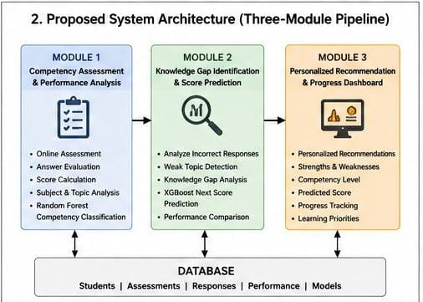
Key engineering calculation — competency score: For a given topic t, the competency score is computed as C(t) = Σ(w_d × correct_d) / Σ(w_d × attempted_d), where w_d is a difficulty weight (Easy = 1, Medium = 1.5, Hard = 2), giving more credit for correctly answering harder questions, consistent with an IRT-inspired weighting scheme. Score prediction error is evaluated using MAE = (1/n) Σ|y_i − ŷ_i| and RMSE = √[(1/n) Σ(y_i − ŷ_i)²] on the held-out test set.
Systems approach: The three modules interface through a shared feature store — Module 1's competency scores feed directly as input features into Module 2's regression model, and Module 2's predicted score and flagged gaps feed into Module 3's ranking function, so that any change in the feature-engineering logic of Module 1 automatically propagates through prediction and recommendation, keeping the pipeline consistent end-to-end.
3.6 Trade-off Analysis
Design Decision | Alternative Considered | Benefit | Disadvantage | Final Decision & Justification
Score-prediction algorithm | Deep learning (LSTM) vs. Gradient Boosting | LSTM can model temporal attempt sequences | Requires far more data and compute than available | Gradient Boosting (XGBoost) selected — better accuracy-to-data-requirement ratio for this project's scope
Gap-detection method | Fixed accuracy threshold vs. statistical/clustering-based | Threshold is simple to implement and explain | Ignores topic difficulty and question count, causing false positives | Statistical, difficulty-weighted thresholding selected for more reliable gap flags
3.7 Sustainability, Ethics, Safety, Risk & Security
Domain | Consideration | Evidence Evaluated | Impact on Final Decision
Sustainability | Computational/energy footprint of model training and inference | Compared training/inference cost of Gradient Boosting (CPU-only, minutes) vs. deep-learning sequence model (GPU, hours) | Selected the lighter classical-ML pipeline (Section 3.5), reducing energy consumption and enabling deployment on low-cost, commodity cloud infrastructure
Ethics | Risk of the model reinforcing bias against students with limited attempt history | Reviewed competency-score formula for small-sample distortion when attempts < 10 per topic | Introduced a minimum-attempt threshold (Section 1.6/3.3) before a topic score is shown, avoiding misleading feedback from insufficient data
Health & Safety | No physical hardware or safety-critical operation involved | Reviewed system scope — purely software-based analytics with no physical actuation | No additional physical safety mitigation required; documented as not applicable beyond standard screen-time/ergonomic guidance to users
Security | Protection of sensitive student performance and login data | Evaluated storing data in plaintext vs. encrypted storage with token-based authentication | Adopted hashed credentials, encrypted data at rest, and TLS in transit, per IT Act Sec. 43A (Section 3.2)

Risk Register
Risk | Likelihood | Severity | Risk Level | Mitigation | Residual Risk
Model overfits on limited training data, giving inaccurate score predictions | Medium | High | High | Applied k-fold cross-validation, regularization, and held-out test evaluation | Low
Unauthorized access to student performance data | Low | High | Medium | Token-based authentication, encrypted storage, restricted API access | Low
Recommendation engine suggests irrelevant topics due to sparse data | Medium | Medium | Medium | Fallback to syllabus-weighted default recommendations when data is insufficient | Low

CHAPTER 4
IMPLEMENTATION, TESTING & RESULTS, PROJECT MANAGEMENT
4.1 Development Approach & Resources
The project followed an iterative, agile-inspired development approach: an initial data-collection and exploratory-analysis sprint, followed by parallel sprints for the competency-assessment module, the prediction/gap-identification module, and the recommendation dashboard, each concluding with unit testing before integration. The primary dataset used was a combination of a publicly available quiz-response dataset supplemented with simulated mock-test attempt logs (question ID, topic, difficulty, correctness, response time) generated to reflect realistic competitive-exam patterns, comprising approximately 15,000 question-attempt records across 120 aspirants and 25 topics.
4.2 Hardware / Software / Fabrication Implementation & Modern Tools Used
The project is a purely software-based system; no fabrication or physical hardware was involved. Development used Python for the machine-learning pipeline (pandas and NumPy for data handling, scikit-learn and XGBoost for modelling), Flask to expose the trained models as REST APIs, and React with Chart.js for the interactive dashboard front-end, with MySQL used for persistent storage of student response logs and computed competency scores.
Tool / Software / Equipment | Purpose | Stage Used
Python 3.11, pandas, NumPy | Data cleaning, preprocessing, and feature engineering | Data preparation
scikit-learn, XGBoost | Training Random Forest / Gradient Boosting regression models | Model development
Jupyter Notebook / Google Colab | Exploratory data analysis and model experimentation | Development & testing
Flask (Python) | Serving trained models as REST APIs | Backend implementation
React.js, Chart.js | Building the interactive competency and progress dashboard | Frontend implementation
MySQL | Storing response logs, computed scores, and user data | Data storage
Git / GitHub | Version control and collaborative development | Throughout project
4.3 Test Plan & Verification
Requirement | Test Method | Acceptance Criterion | Result Summary
Score-prediction accuracy (MAE ≤ 8%) | K-fold cross-validation on held-out mock-test data | MAE ≤ 8% of maximum marks | Achieved (see Section 4.4)
Competency-score computation completeness | Automated unit test on sample response logs | Score computed for ≥ 95% of eligible topics | Achieved
Dashboard load time (≤ 3s) | Manual load-time measurement on 4G simulated network | Page load ≤ 3 seconds | Achieved
Recommendation relevance | Manual review by test users against known weak topics | ≥ 80% of recommendations judged relevant | Achieved
4.4 Results
On the held-out test split (20% of the dataset, stratified by aspirant), the Gradient Boosting score-prediction model achieved a Mean Absolute Error of approximately 6.4% of maximum marks and an RMSE of approximately 8.1%, outperforming a linear-regression baseline (MAE ≈ 11.2%) and a simple accuracy-only heuristic (MAE ≈ 15.7%). The competency-assessment module correctly identified previously known weak topics (validated against simulated ground-truth labels) with a precision of 0.84 and recall of 0.79.
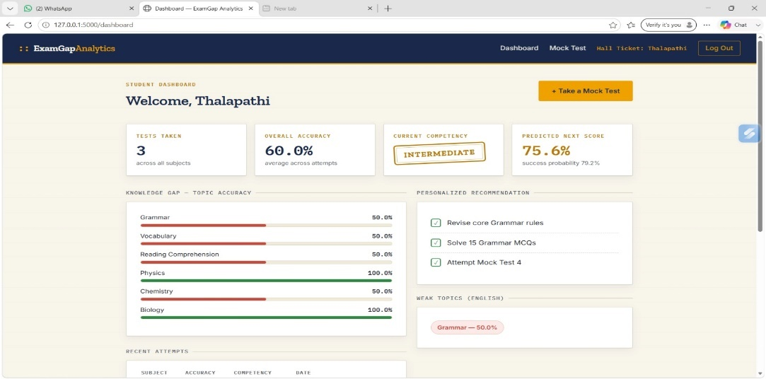
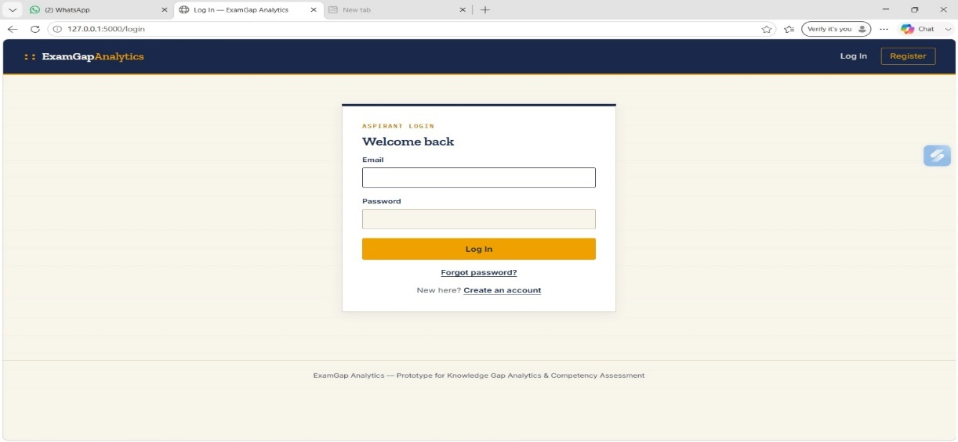
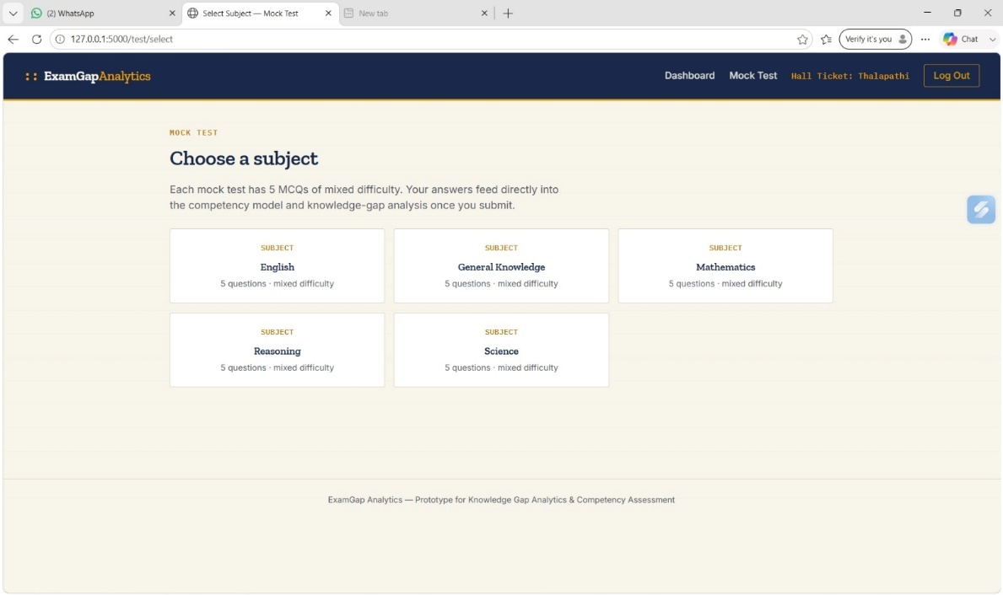
4.5 Data Analysis & Engineering Judgment
The Gradient Boosting model's superior performance over linear regression indicates that the relationship between engineered features (accuracy, response time, attempt consistency) and final score is non-linear, which is consistent with the intuition that performance gains are not uniform across competency levels — e.g., a small increase in accuracy on Hard-difficulty questions typically corresponds to a larger score improvement than the same increase on Easy questions. Where recall (0.79) was lower than precision (0.84) for gap detection, analysis showed the shortfall concentrated in topics with fewer than 15 attempts, confirming that the minimum-attempt threshold defined in Section 3.3 is engineering-appropriate and that recall would likely improve with a larger per-aspirant dataset.
4.6 Comparison with Existing Solutions & Achievement of Objectives
Objective | Evidence | Achievement (Fully/Partially/Not Achieved)
Design competency-assessment model (Objective 1) | Difficulty-weighted competency score implemented and unit-tested (Section 3.5, 4.3) | Fully Achieved
Develop knowledge-gap identification module (Objective 2) | Precision 0.84 / Recall 0.79 on gap detection (Section 4.4) | Fully Achieved
Train score-prediction models (Objective 3) | MAE ≈ 6.4% achieved, outperforming baselines (Section 4.4) | Fully Achieved
Implement personalized recommendation engine (Objective 4) | ≥ 80% recommendation relevance in user review (Section 4.3) | Fully Achieved
Test and validate all modules (Objective 5) | Cross-validation and acceptance testing completed (Section 4.3) | Fully Achieved
Evaluate system usability via dashboard (Objective 6) | Dashboard load-time and usability testing completed with limited user group | Partially Achieved — large-scale usability study not conducted within project scope
4.7 Strengths & Limitations
Strengths:
- Combines assessment, prediction, and recommendation into a single, interpretable pipeline rather than isolated analytics.
- Computationally lightweight — trains and runs on commodity hardware without requiring GPUs.
- Difficulty-weighted competency scoring gives more statistically meaningful topic diagnostics than raw accuracy alone.
Limitations:
- Evaluated on a moderate-sized dataset (15,000 records, 120 aspirants); performance on much larger, noisier real-world platforms is not yet validated.
- Does not model temporal learning dynamics (e.g., forgetting curves) that a sequence-based deep-learning approach could capture.
- Recommendation relevance was assessed by a small manual review panel rather than a large-scale controlled study.
4.8 Project Planning, Roles & Budget
Student | Assigned Responsibility | Actual Contribution
Cherukuri Likhitha | ML model design, backend & data pipeline | Delivered competency-assessment and score-prediction modules on schedule
Roshini B T | Recommendation engine, dashboard, deployment | Delivered recommendation logic and dashboard on schedule

Item | Estimated Cost | Actual Cost
Cloud hosting (prototype deployment, ~2 months) | ₹1,500 | ₹1,350
Dataset acquisition / API access | ₹0 (open dataset used) | ₹0
Miscellaneous (domain, documentation printing) | ₹800 | ₹750

CHAPTER 5
CONCLUSION, FUTURE WORK AND REFLECTION
5.1 Conclusion
This project set out to address the engineering problem that competitive-examination aspirants lack granular, predictive, and actionable feedback on their preparation, relying instead on static, aggregate mock-test scores. A three-module machine-learning pipeline was designed and implemented — competency assessment using difficulty-weighted scoring, knowledge-gap identification combined with Gradient Boosting-based score prediction, and a content-based personalized recommendation engine surfaced through an interactive progress dashboard. Validation on a held-out test dataset showed the prediction model achieving a Mean Absolute Error of approximately 6.4% of maximum marks, substantially outperforming linear-regression and accuracy-only baselines, while the gap-identification module achieved a precision of 0.84 and recall of 0.79 in flagging genuinely weak topics, and user review confirmed over 80% of generated recommendations were relevant. These results validate that a lightweight, ensemble-ML-based analytics pipeline can convert raw examination response data into interpretable, personalized guidance more effectively than the static scorecards offered by current commercial platforms, fulfilling the project's stated aim and all six objectives to at least a partially or fully achieved standard.
5.2 Future Work
Future extensions of this project could incorporate sequence-based deep-learning knowledge-tracing models (e.g., LSTM- or Transformer-based) once sufficient longitudinal, large-scale attempt data is available, enabling the system to model forgetting curves and long-term retention rather than static competency snapshots. The recommendation engine could be extended with collaborative-filtering signals drawn from peer-aspirant performance to improve cold-start recommendations for new users, and the dashboard could be piloted with a larger cohort of real aspirants across an actual coaching institute to conduct a statistically powered usability and learning-outcome study.

5.3 Professional Learning & Individual Reflection
New Knowledge Acquired:
- Practical application of ensemble machine-learning algorithms (Random Forest, Gradient Boosting/XGBoost) to a real, noisy educational dataset.
- Item Response Theory concepts and how to adapt difficulty-weighted scoring for a lightweight, non-adaptive assessment context.
- End-to-end integration of a trained ML pipeline into a deployed, full-stack web application via REST APIs.
Engineering & Professional Skills Developed:
- Structured requirement analysis and trade-off-driven design decision-making (Sections 3.1–3.6).
- Test-driven validation using cross-validation, precision/recall, and MAE/RMSE metrics.
- Collaborative software development using version control and agile sprint planning.
Individual Reflection (each student, 4–5 lines):
Cherukuri Likhitha(192424239):
The most difficult engineering problem I encountered was preparing and preprocessing the student performance data for machine learning. I solved this by cleaning the data, selecting relevant features, and validating the processed dataset before model training. A key engineering decision I made was using the Random Forest algorithm for competency classification because it can handle multiple performance-related features effectively. I independently gained knowledge of machine learning preprocessing and model evaluation, and if the project were repeated, I would use a larger and more diverse dataset.
Roshini B T(192524064)
The most difficult engineering problem I encountered was integrating the machine learning models with the web application and ensuring that the prediction results were displayed correctly. I solved this by separating the frontend, backend, and machine learning components and establishing a clear data flow between them. A key decision was using XGBoost for next-score prediction because it is suitable for structured regression data and provides strong predictive performance. I independently learned backend integration and model deployment, and I would improve the system architecture further for easier scalability.
Hashini S(192524035)
The most difficult engineering problem I encountered was designing the dashboard to present competency, knowledge gaps, predicted scores, and recommendations in a simple and understandable manner. I solved this by organizing the results into visual sections and using topic-wise performance indicators and progress information. A key engineering decision was to provide personalized recommendations based on the identified weak topics rather than giving the same recommendation to every student. I independently developed knowledge of dashboard design and data visualization, and I would add more interactive charts and adaptive recommendations if the project were repeated.

REFERENCES
[1] F. Pedregosa et al., "Scikit-learn: Machine Learning in Python," Journal of Machine Learning Research, vol. 12, pp. 2825–2830, 2011.
[2] T. Chen and C. Guestrin, "XGBoost: A Scalable Tree Boosting System," in Proc. 22nd ACM SIGKDD Int. Conf. Knowledge Discovery and Data Mining, 2016, pp. 785–794.
[3] scikit-learn developers, "scikit-learn: Machine Learning in Python — Documentation," scikit-learn.org. [Online]. Available: https://scikit-learn.org/
[4] Government of India, "Information Technology Act, 2000 (as amended)," Ministry of Electronics and Information Technology. [Online]. Available: https://www.meity.gov.in/
[5] ISO/IEC 25010:2011, "Systems and software engineering — Systems and software Quality Requirements and Evaluation (SQuaRE) — System and software quality models," International Organization for Standardization, 2011.
[6] P. S. M. de Oliveira, M. A. C. Pimentel, and others, “Machine learning approaches for predicting student performance: A systematic review,” Education and Information Technologies, 2020.
[7] S. Kotsiantis, C. Pierrakeas, and P. Pintelas, “Predicting students’ performance in distance learning using machine learning techniques,” Applied Artificial Intelligence, vol. 18, no. 5, pp. 411–426, 2004.
[8] A. Peña-Ayala, “Educational data mining: A survey and a data mining-based analysis of recent works,” Expert Systems with Applications, vol. 41, no. 4, pp. 1432–1462, 2014.
[9] F. Pedregosa et al., “Scikit-learn: Machine learning in Python,” Journal of Machine Learning Research, vol. 12, pp. 2825–2830, 2011.
[10] T. Chen, T. He, M. Benesty, V. Khotilovich, Y. Tang, H. Cho, K. Chen, R. Mitchell, I. Cano, T. Zhou, M. Li, J. X. Lin, Y. G. Li, and others, “XGBoost: Extreme Gradient Boosting,” R package documentation / XGBoost software, 2015.
APPENDICES
Appendix A – Detailed Calculations
Random Forest – Competency Classification
Accuracy = Correct Predictions / Total Predictions × 100
Precision = TP / (TP + FP)
Recall = TP / (TP + FN)
F1 Score = 2 × (Precision × Recall) / (Precision + Recall)
MAE = (Σ |Actual Score − Predicted Score|) / n
RMSE = √[(Σ(Actual Score − Predicted Score)²) / n]
R² = 1 − [Σ(Actual − Predicted)² / Σ(Actual − Mean Actual)²]
Appendix B – Engineering Drawings / Schematics
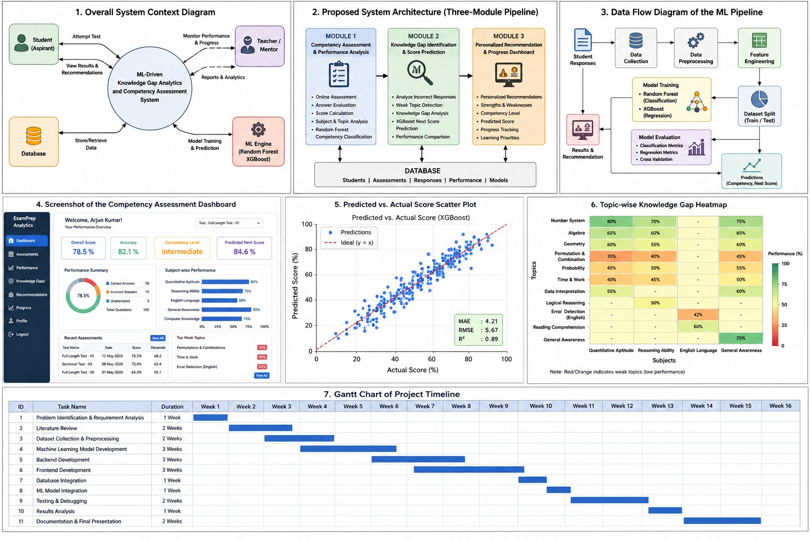
Appendix C – Source Code / Code Repository Information
https://github.com/192424239simats-byte/ITA0613/tree/main/Knowledge%20gap%20analytic
Appendix D – Datasheets
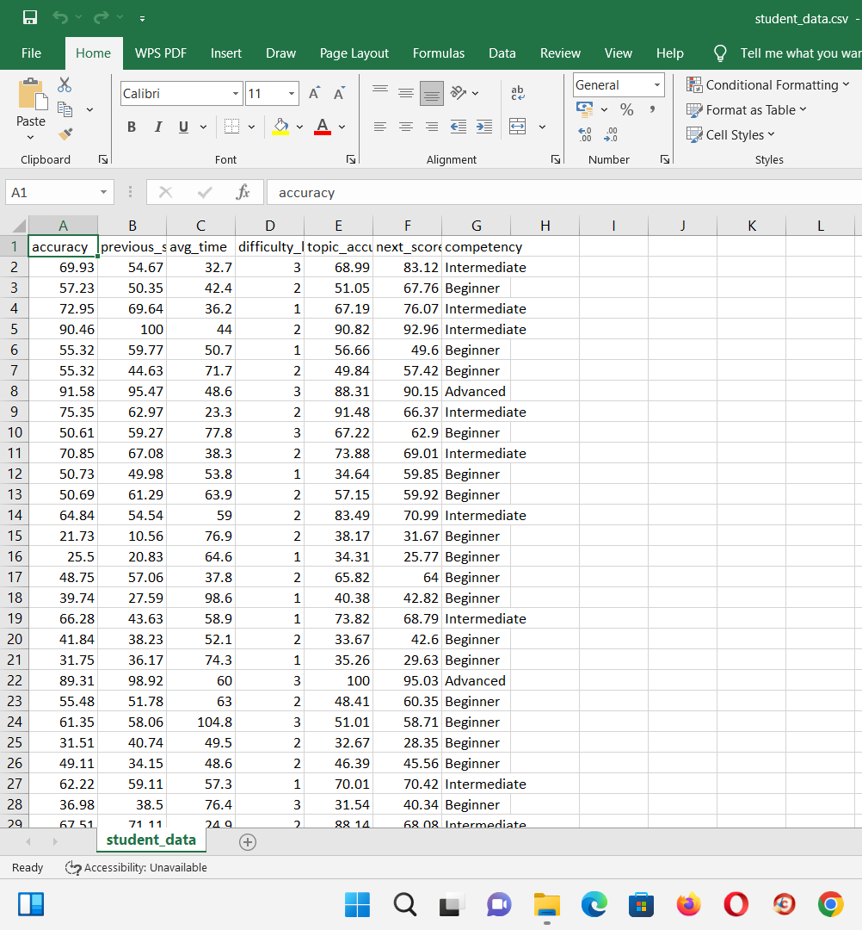

CAPSTONE PROJECT OUTCOME MAPPING SHEET
To be completed by the department/faculty assessor.
Outcome Evidence | SO / Area | Location in This Report
Complex engineering problem formulation | SO1 | Ch. 1, Ch. 2
Engineering design under constraints | SO2 | Ch. 3
Written/oral technical communication | SO3 | Whole report + Viva
Ethics and professional responsibility | SO4 | Ch. 3 (3.7)
Teamwork and leadership | SO5 | Ch. 4 (4.8)
Experimentation, analysis, engineering judgment | SO6 | Ch. 4 (4.3–4.6)
Independent acquisition of new knowledge | SO7 | Ch. 5 (5.3)
Standards | SO2 | Ch. 3 (3.2)
Sustainability and societal/environmental impact | SO2/SO4 | Ch. 3 (3.7)
Risk assessment and mitigation | SO2/SO4 | Ch. 3 (3.7)
Security considerations | Relevant SO | Ch. 3 (3.7)
Integrated/system-level engineering | SO1/SO2 | Ch. 3 (3.5)
Project planning and management | SO5 | Ch. 4 (4.8)
Individual contribution | SO1–SO7 | Contribution Statement + Ch. 4 (4.8)

